Indexed Sequential File
# Source: AI Source: Provided by: [Data Path: Persons Table -> ID Column: 1, Name_En Column: Motasem Essam] -> From: [Chatgpt (GPT‑5 Mini)] on [1/26/2026]
An Indexed Sequential File is a file organization method that combines the features of Sequential File and Indexed File.
👉 Records are stored sequentially, but an index is also created to allow fast access.

Definition
# Source: AI Source: Provided by: [Data Path: Persons Table -> ID Column: 1, Name_En Column: Motasem Essam] -> From: [Chatgpt (GPT‑5 Mini)] on [1/26/2026]
An Indexed Sequential File stores records:
- in sequential order (usually by a key field), and
- uses an index to quickly locate records.

How It Works
# Source: AI Source: Provided by: [Data Path: Persons Table -> ID Column: 1, Name_En Column: Motasem Essam] -> From: [Chatgpt (GPT‑5 Mini)] on [1/26/2026]
- Records are stored in order (e.g., by StudentID).
- An index stores key values and pointers to record locations.
- To find a record:
  - First search the index.
  - Then jump directly to the required position in the file.

Example
# Source: AI Source: Provided by: [Data Path: Persons Table -> ID Column: 1, Name_En Column: Motasem Essam] -> From: [Chatgpt (GPT‑5 Mini)] on [1/26/2026]

Data File (Sequential)
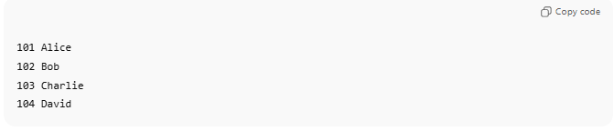
101 Alice
102 Bob
103 Charlie
104 David
Index
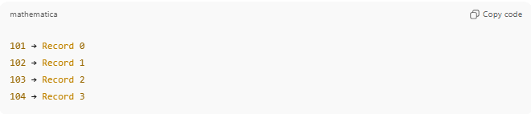
101 → Record 0
102 → Record 1
103 → Record 2
104 → Record 3
- To find Charlie (103) → use index → go directly to record 2.
- To process all students → read sequentially from 101 to 104.

Advantages
# Source: AI Source: Provided by: [Data Path: Persons Table -> ID Column: 1, Name_En Column: Motasem Essam] -> From: [Chatgpt (GPT‑5 Mini)] on [1/26/2026]
✔ Faster access than sequential files
✔ Supports both sequential processing and direct access
✔ Efficient for large files

Disadvantages
# Source: AI Source: Provided by: [Data Path: Persons Table -> ID Column: 1, Name_En Column: Motasem Essam] -> From: [Chatgpt (GPT‑5 Mini)] on [1/26/2026]
❌ More storage needed for index
❌ More complex than sequential files

Where It Is Used
# Source: AI Source: Provided by: [Data Path: Persons Table -> ID Column: 1, Name_En Column: Motasem Essam] -> From: [Chatgpt (GPT‑5 Mini)] on [1/26/2026]
- Banking systems
- Payroll systems
- Student record systems

Comparison Summary
# Source: AI Source: Provided by: [Data Path: Persons Table -> ID Column: 1, Name_En Column: Motasem Essam] -> From: [Chatgpt (GPT‑5 Mini)] on [1/26/2026]
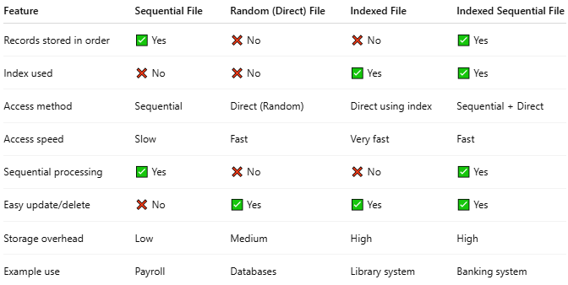
Feature | Sequential File | Random (Direct) File | Indexed File | Indexed Sequential File
Records stored in order | ✅ Yes | ❌ No | ❌ No | ✅ Yes
Index used | ❌ No | ❌ No | ✅ Yes | ✅ Yes
Access method | Sequential | Direct (Random) | Direct using index | Sequential + Direct
Access speed | Slow | Fast | Very fast | Fast
Sequential processing | ✅ Yes | ❌ No | ❌ No | ✅ Yes
Easy update/delete | ❌ No | ✅ Yes | ✅ Yes | ✅ Yes
Storage overhead | Low | Medium | High | High
Example use | Payroll | Databases | Library system | Banking system

💡 Analogy:
# Source: AI Source: Provided by: [Data Path: Persons Table -> ID Column: 1, Name_En Column: Motasem Essam] -> From: [Chatgpt (GPT‑5 Mini)] on [1/26/2026]
- Sequential File → List in order
- Indexed File → Index only
- Indexed Sequential File → Ordered list with an index

